Configuring Permissions Solution

Exercise 1: Investigation

Answer the following questions using the Security Dictionary.

1. All of the system permissions which pertain to activities start with the letters "act". How many system permissions are there that pertain to activities?  
17

2. Are the activity system permissions all static, all object-based, or are there some of each?  
There are some of each. For example, actapproveany is static, but actcreate is object-based.

3. What is the name of the system permission a user must have to own an activity? How many roles is this permission currently assigned to?  
actown; 7 (Adjuster, Claims Supervisor, Clerical, Manager, New Loss Processing Supervisor, Reinsurance Manager, Superuser)

4. How many permissions are associated to the Catastrophe Admin role?  
3 (catmanage, catview, usereditlang)

5. Of the five application permission keys that pertain to notes, which one has the largest number of related permissions?  
Note view

6. Of the five application permission keys that pertain to notes, which one is static?  
Note create

7. VoidStopCheck is a page in the user interface. Are any permissions needed to view the page? To edit it?  
To view: perm.Claim.viewpayments(Claim); To edit: none

Exercise 2: Configuration

Creating a custom permission

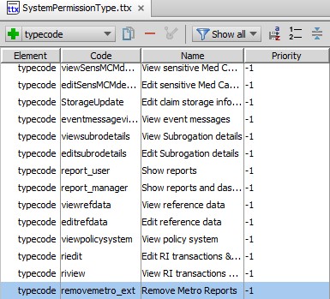

Adding the system permission to the Claim Supervisor Role

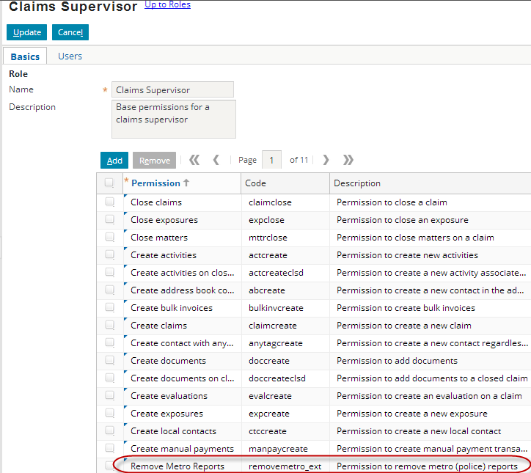

Limiting the add/remove buttons to users with the new permission.

